Rectifier Thyristor Technology - Water-Cooled

水冷型可控硅整流器技术

[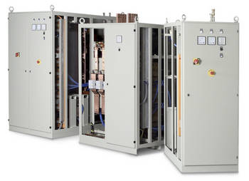](http://www.munk.de/fileadmin/_processed_/csm_Munk_Thyristor_Wasser_17f94892b2.jpg)

Application:

应用：

Aluminium Anodizing, Electrolytic Brightening, Electrolysis, Galvanic High-Current Applications, Strip Refinement, Pulse Applications

铝氧化，电解抛光，电解，大电流电镀应用，薄带电镀，脉冲电镀

Product Description:

产品说明：

Especially in the fields of High-Current Processes water cooling has become established. As a cooling medium, water is considerably better at achieving a high packing density. The well-proven Thyristor Technology combines wear-free capacity adjustment and dynamic process developments. A power supply system which can be integrated individually in any plant concept.

水冷却的方式已经得到业界认可，尤其在大电流工艺的行业中。水作为冷却介质，能够更好地实现一种高密度的“包装”冷却方式；再加上成熟的可控硅技术集成了无损耗的流量调节技术和动态过程开发，使我们的电源单元系统应用于任何一个工厂车间。

Our Thyristor Technology is also available in [oil-cooling](http://www.munk.de/en/produkte/dc-power-supplies/oil-cooled/thyristor-technology/), [oil-water-cooling](http://www.munk.de/en/produkte/dc-power-supplies/oil-water-cooled/thyristor-technology/) and [air-cooling.](http://www.munk.de/en/produkte/dc-power-supplies/air-cooled/rectifier-thyristor-technology/)

当然我们的可控硅冷却技术也有油冷，油水冷和风冷。

Block Diagram:

原理：

[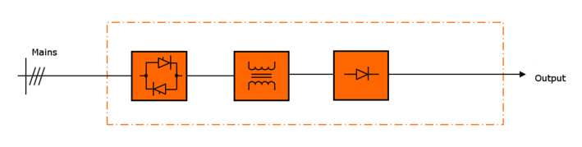](http://www.munk.de/fileadmin/_processed_/csm_Blockschaltbild_Thyristor_Wasser_prim_en_c7c7aee40d.png)

Functional Description:

功能说明：

Capacity adjustement is achieved either on the primary side or on the secondary side of the device. Using a power switch or fuse elements and main contactor ensures safe mains separation. Galvanic mains separation is achieved by the main transformer. A 6-pulse rectification meets the requirements which are relevant to the process. By means of additional smoothing elemnts almost all desired ripples can be realized. All main components such as semiconductors, transformer, bars are being cooled which enables a high packing density.

电流流量调节可以通过在设备的初次侧或者二次侧实现，同时用电力开关或者快熔元件和主接触器以确保达到安全隔离；而直流电主要通过主变压器实现隔离。六相整流器技术符合相关工艺的要求，通过额外的滤波元件几乎可实现最完美的波纹。设备的所有主要元件都是采用高密度的“包装”水冷方式，如半导体，变压器，输出铜排等。

Customer Benefits:

客户利益：

MUNK Thyristor Technology in water cooling is perfected to the special needs in power conversion and is particularly recommended for high-power applications or when size matters. Cooling a rectifier by means of water is most efficient because the water is recycled in a cooling loop and can be re-used for cooling the most powerful rectifiers even if the ambient temperature exceeds 40 °C.

MUNK水冷型可控硅技术完善了功率转换的特殊需求，尤其推荐用于高功率设备或者更大规模的应用。冷却一台整流器的水可以在冷却回路中循环利用，而且即使环境温度超过了40°C也可以重新用于冷却最大功率的整流器。

Technical Data:

**技术参数：**

|  |  |
| --- | --- |
| Mains Voltage:  进线电压： | 3 x 400 V / 50 Hz + N + PE(+all usual mains voltages or 60 Hz)  3 x 400 V / 50 Hz + N + PE(常规电压或者 60 Hz) |
|  |  |
| Output Current:  输出电流： | 1000 A - 100.000 A |
| Output Voltage:  输出电压： | 6 V - 900 V |
| Ripple (standard):  波纹（标准）： | approx. 5 % at full load  满负载状态下大约5% |
| Ripple (Option):  波纹（可选）: | 2 - 3 % at full load  满负载状态下大约2-3% |
| Duty Factor:  工作系数： | 100 % (24/7) |
| Efficiency:  效率： | 80 % - 93 % |
| Ambient Temperature:  环境温度: | + 35 °C |
|  | + 40 °C (Option)  + 40 °C (可选) |
| Cooling:  冷却方式： | Water  水 |
| Water inlet temperature:  进水温度： | + 16 °C - + 35 °C |
| Protection Grade:  防护等级： | IP 23 - IP 54 |

**通讯接口:**

Analog 0-10 VDC  
0(4)...20 mA  
Profibus DP  
PROFINET

**产品目录：**

http://www.munk.de/fileadmin/_processed_/csm_Thyristor_w_gb_web_351061a91f.gif

* [Brochure\_Thyristor\_water.pdf (212 K)](http://www.munk.de/fileadmin/contents/Bilder/Produkte/Thyristortechnik/Thyristor_w_gb_web.pdf" \t "_blank)

[PRODUCT ENQUIRY FORM](http://www.munk.de/en/kontakt/product-enquiry-form/)